Mixed Concentric Shapes

Definition
# Source: AI Source: Provided by: [Data Path: Persons Table -> ID Column: 1, Name_En Column: Motasem Essam] -> From: [ChatGPT] on [7/25/2026]
Mixed Concentric Shapes are arrangements of two or more different types of shapes that share a common center or central point of reference.
Unlike a set of concentric circles or concentric polygons, a mixed concentric arrangement combines different geometric forms around the same center.
For example, a circle, square, and regular polygon can be arranged around the same center:
$$O_{1}=O_{2}=O_{3}=O$$
The shapes may differ in their boundary type, number of sides, curvature, or geometric structure, while maintaining a common central organization.
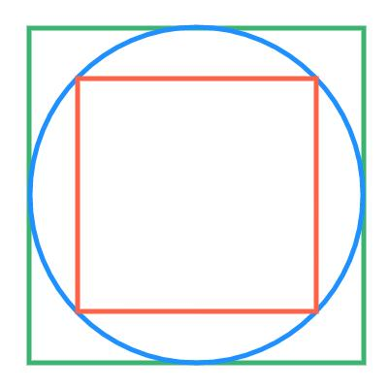
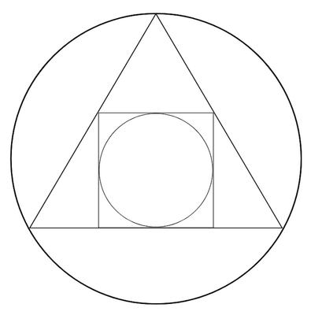
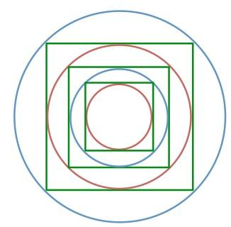
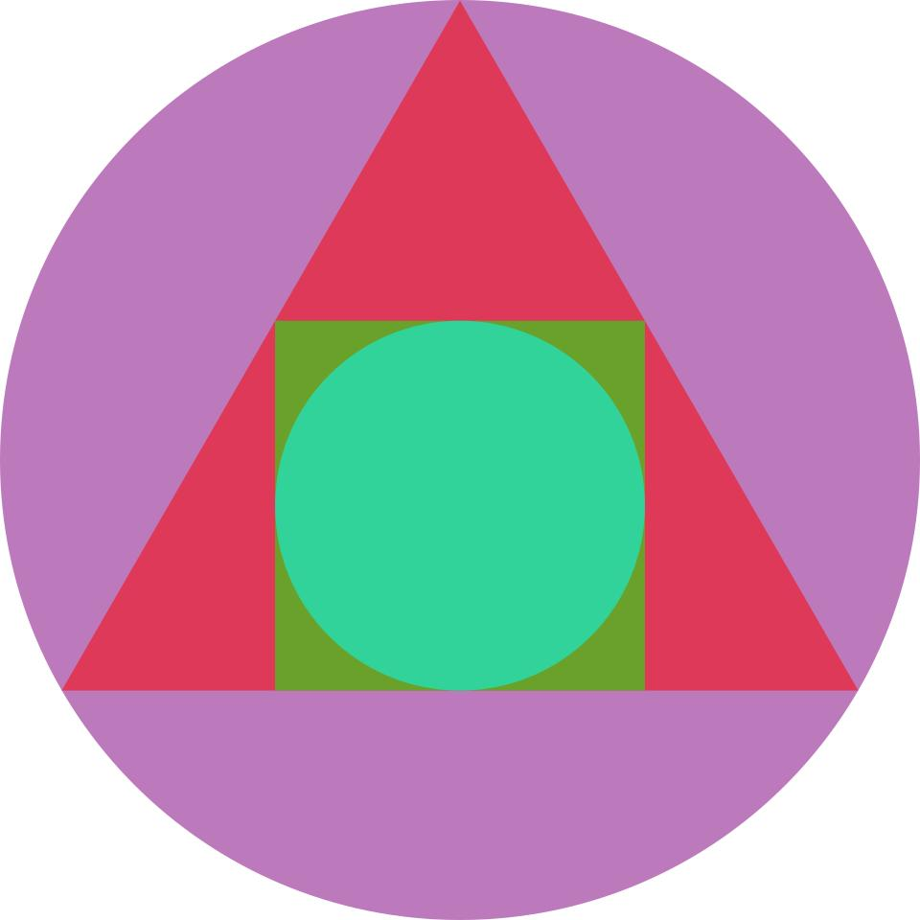
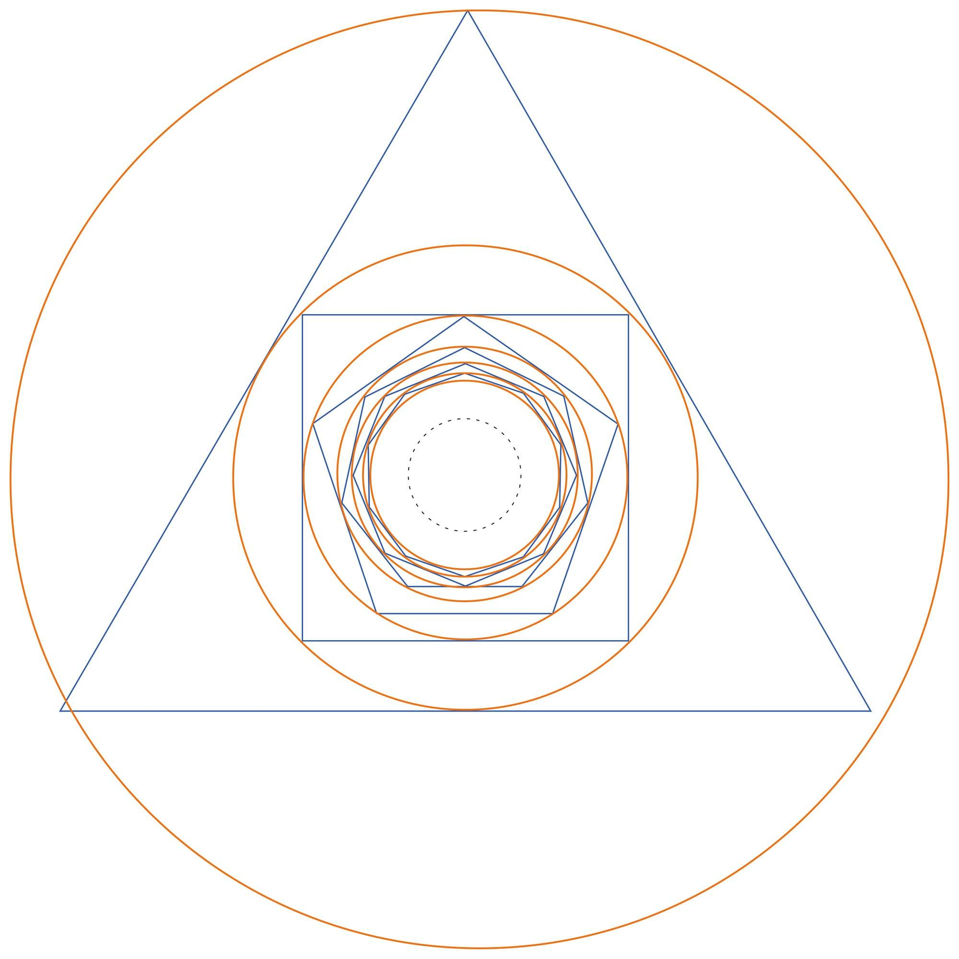
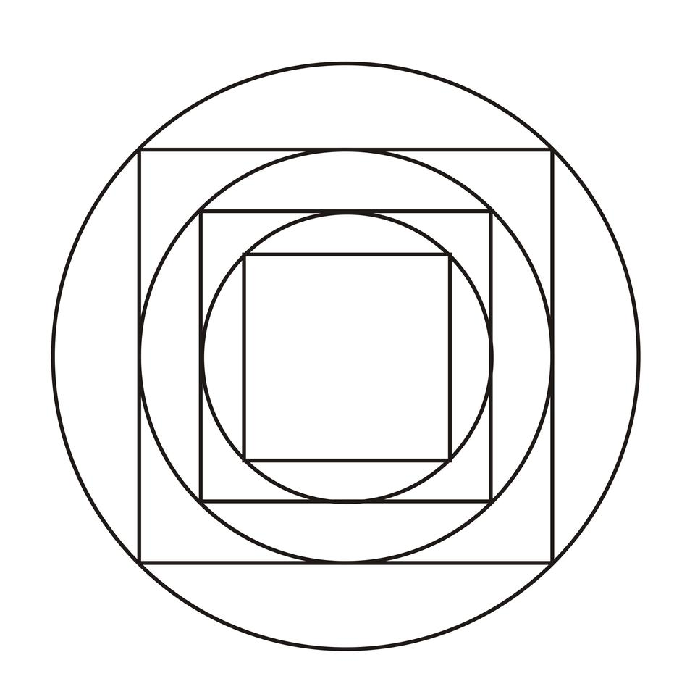

Fundamental Concept
# Source: AI Source: Provided by: [Data Path: Persons Table -> ID Column: 1, Name_En Column: Motasem Essam] -> From: [ChatGPT] on [7/25/2026]
The fundamental idea is:
Different shapes + common center + nested or centrally organized arrangement
For example:
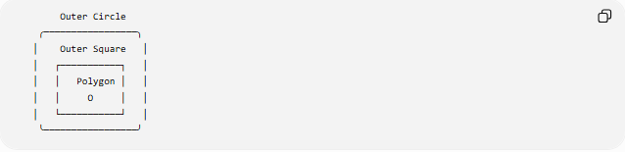
Outer Circle
╭─────────────────╮
│ Outer Square │
│ ┌───────────┐ │
│ │ Polygon │ │
│ │ O │ │
│ └───────────┘ │
╰─────────────────╯
The shapes do not need to be the same type.
The important characteristic is that their geometric placement is organized around the same center $O$.

Main Characteristics
# Source: AI Source: Provided by: [Data Path: Persons Table -> ID Column: 1, Name_En Column: Motasem Essam] -> From: [ChatGPT] on [7/25/2026]
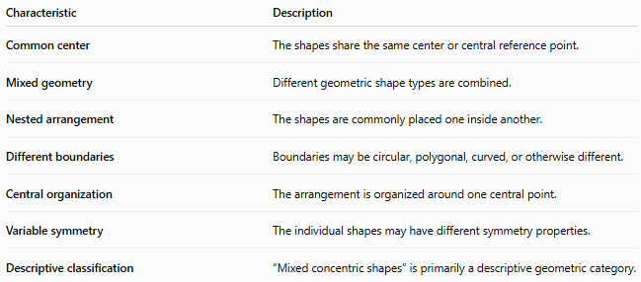
Characteristic | Description
Common center | The shapes share the same center or central reference point.
Mixed geometry | Different geometric shape types are combined.
Nested arrangement | The shapes are commonly placed one inside another.
Different boundaries | Boundaries may be circular, polygonal, curved, or otherwise different.
Central organization | The arrangement is organized around one central point.
Variable symmetry | The individual shapes may have different symmetry properties.
Descriptive classification | “Mixed concentric shapes” is primarily a descriptive geometric category.

Basic Structure
# Source: AI Source: Provided by: [Data Path: Persons Table -> ID Column: 1, Name_En Column: Motasem Essam] -> From: [ChatGPT] on [7/25/2026]
A mixed concentric arrangement can contain shapes such as:
- Circle
- Square
- Triangle
- Pentagon
- Hexagon
- Ellipse
- Other centrally organized closed shapes
For example:
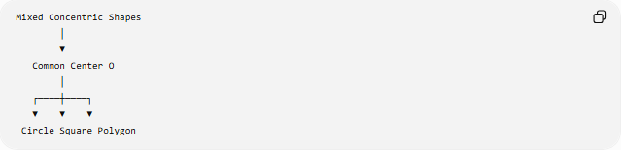
Mixed Concentric Shapes
│
▼
Common Center O
│
┌────┼────┐
▼ ▼ ▼
Circle Square Polygon
The shapes do not need to have the same number of sides or the same boundary type.

Types of Mixed Concentric Shapes
# Source: AI Source: Provided by: [Data Path: Persons Table -> ID Column: 1, Name_En Column: Motasem Essam] -> From: [ChatGPT] on [7/25/2026]
A useful classification is:
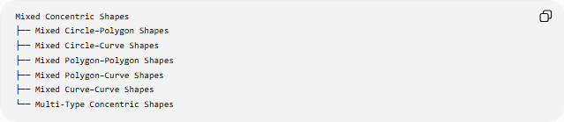
Mixed Concentric Shapes
├── Mixed Circle–Polygon Shapes
├── Mixed Circle–Curve Shapes
├── Mixed Polygon–Polygon Shapes
├── Mixed Polygon–Curve Shapes
├── Mixed Curve–Curve Shapes
└── Multi-Type Concentric Shapes
These categories describe which types of boundaries are combined.

Mixed Circle–Polygon Concentric Shapes
# Source: AI Source: Provided by: [Data Path: Persons Table -> ID Column: 1, Name_En Column: Motasem Essam] -> From: [ChatGPT] on [7/25/2026]
A mixed circle–polygon concentric arrangement combines circular and polygonal boundaries around the same center.
Examples include:
- Circle + square
- Circle + triangle
- Circle + hexagon
- Circle + multiple polygons
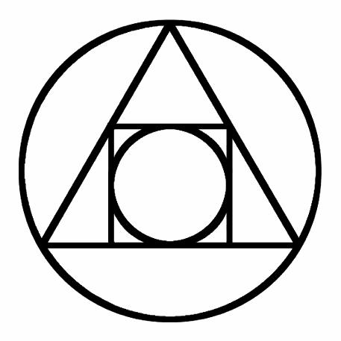
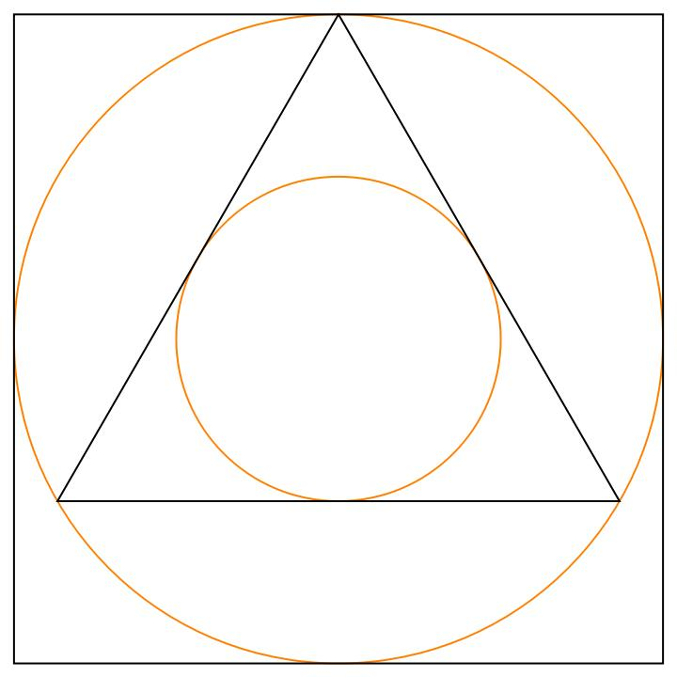
For a circle centered at $O=\left(h , k\right)$:
$${\left(x-h\right)}^{2}+{\left(y-k\right)}^{2}=r^{2}$$
A regular polygon can be centered at the same $O$.
The two shapes therefore have a common central reference point even though their boundaries are different.

Mixed Circle–Curve Concentric Shapes
# Source: AI Source: Provided by: [Data Path: Persons Table -> ID Column: 1, Name_En Column: Motasem Essam] -> From: [ChatGPT] on [7/25/2026]
A mixed circle–curve arrangement combines a circle with another centrally organized curve.
Examples include:
- Circle + ellipse
- Circle + rounded curve
- Circle + centrally scaled closed curve
For example, a circle and ellipse can both have center:
$$O=\left(h , k\right)$$
while their shapes remain different.
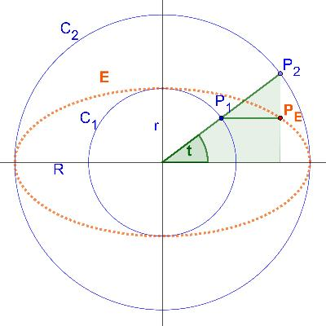
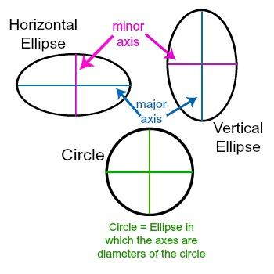
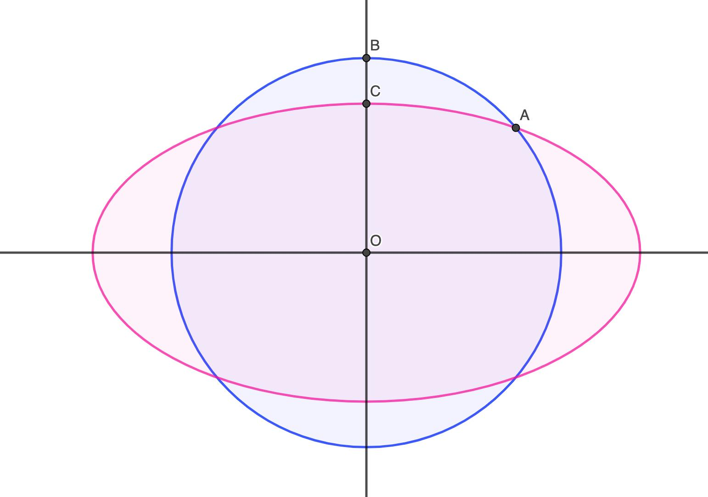
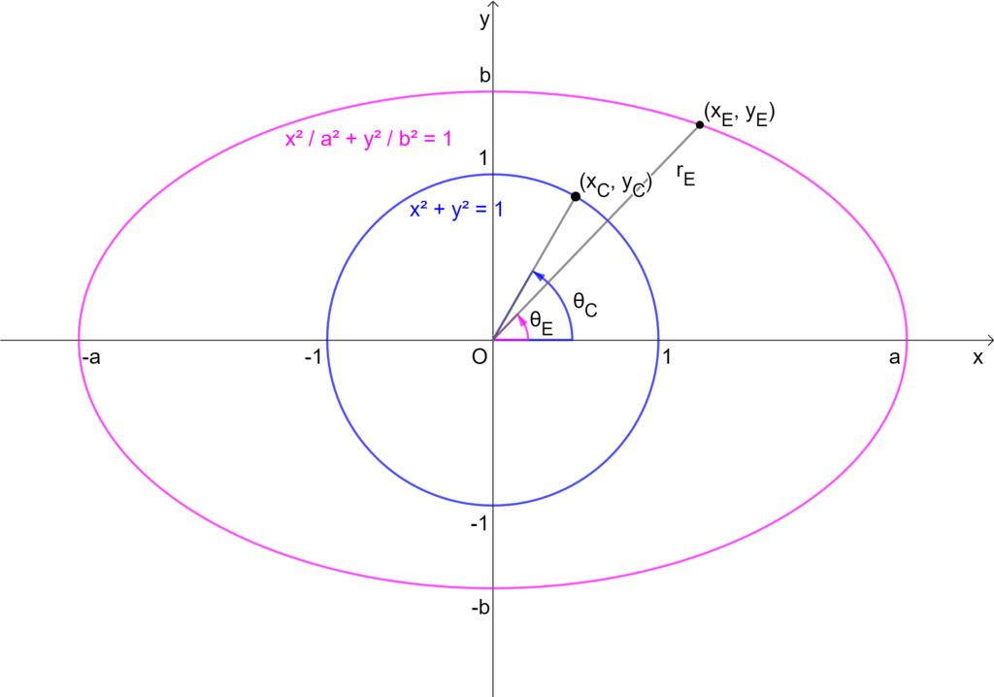
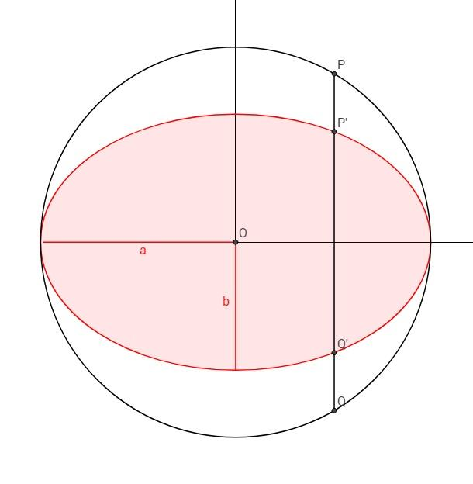

Mixed Polygon–Polygon Concentric Shapes
# Source: AI Source: Provided by: [Data Path: Persons Table -> ID Column: 1, Name_En Column: Motasem Essam] -> From: [ChatGPT] on [7/25/2026]
Two or more different polygon types can be arranged around a common center.
Examples:
- Square + hexagon
- Triangle + hexagon
- Pentagon + octagon
For example:
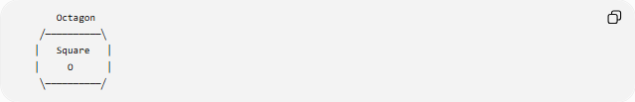
Octagon
╱──────────╲
│ Square │
│ O │
╲──────────╱
The polygons can have different numbers of sides while sharing the same center.

Mixed Polygon–Curve Concentric Shapes
# Source: AI Source: Provided by: [Data Path: Persons Table -> ID Column: 1, Name_En Column: Motasem Essam] -> From: [ChatGPT] on [7/25/2026]
A mixed polygon–curve arrangement combines a polygon with a curved boundary.
Examples include:
- Square + circle
- Hexagon + ellipse
- Pentagon + closed curve
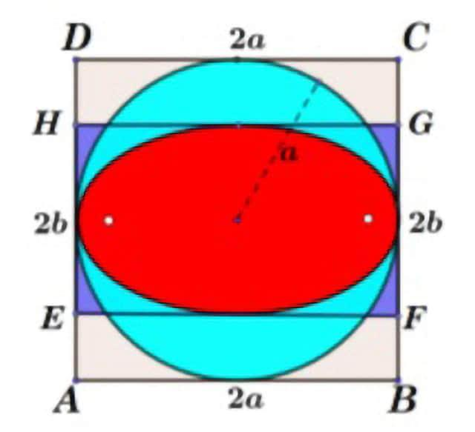
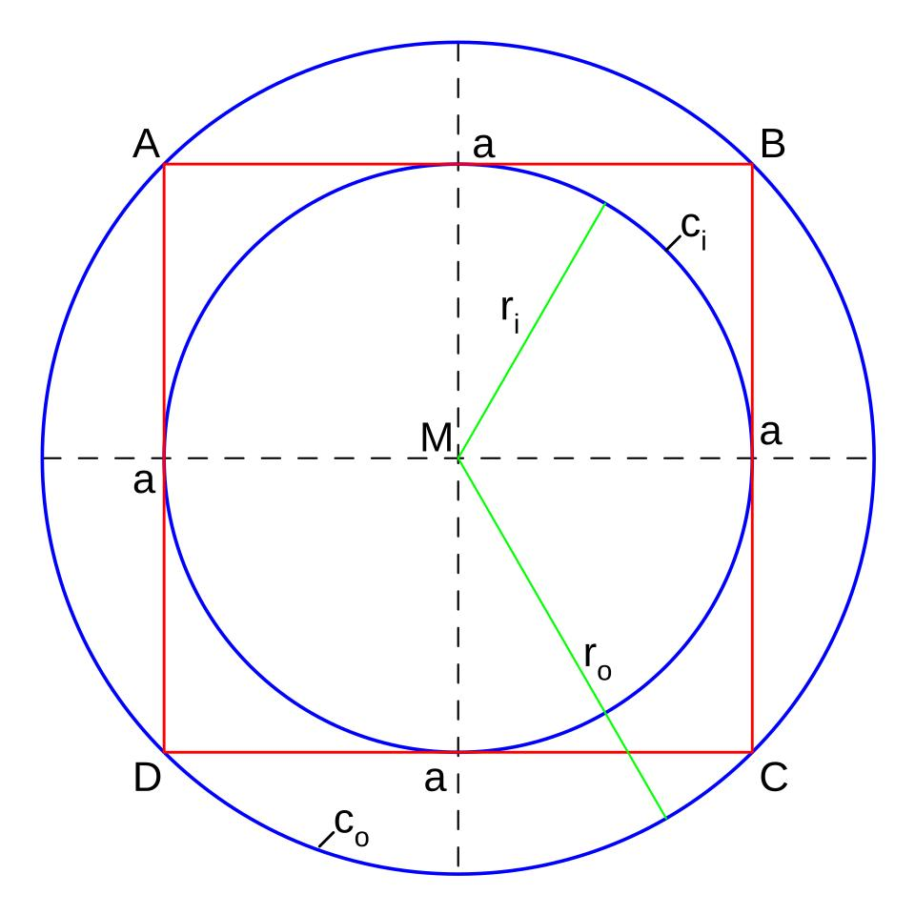
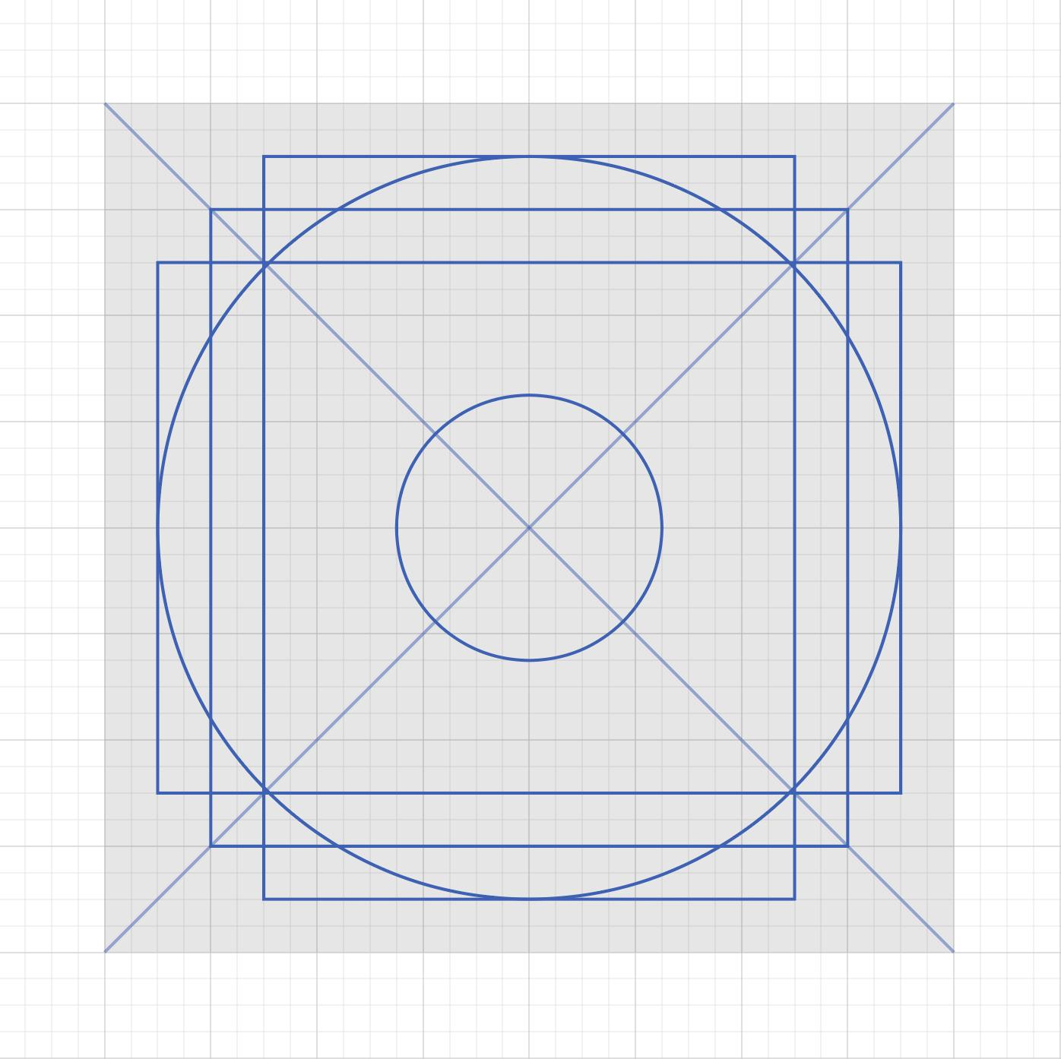
This type is especially useful for illustrating the difference between:
- straight-sided boundaries
- curved boundaries
while maintaining a common central organization.

Mixed Curve–Curve Concentric Shapes
# Source: AI Source: Provided by: [Data Path: Persons Table -> ID Column: 1, Name_En Column: Motasem Essam] -> From: [ChatGPT] on [7/25/2026]
Two or more different curves can share the same center.
Examples include:
- Circle + ellipse
- Ellipse + another centrally scaled ellipse
- Circle + another centrally organized closed curve
The curves may differ in shape while maintaining:
$$O_{1}=O_{2}=O$$
This is related to the broader concept of concentric curves.

Multi-Type Concentric Shapes
# Source: AI Source: Provided by: [Data Path: Persons Table -> ID Column: 1, Name_En Column: Motasem Essam] -> From: [ChatGPT] on [7/25/2026]
A multi-type concentric arrangement contains three or more different types of shapes.
For example:
$$\text{Circle}+\text{Square}+\text{Triangle}+\text{Ellipse}$$
can be organized around a common center.
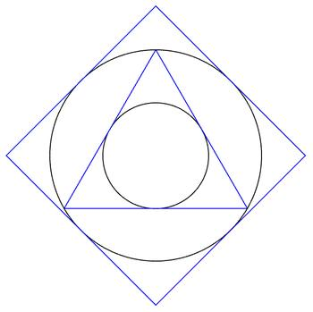
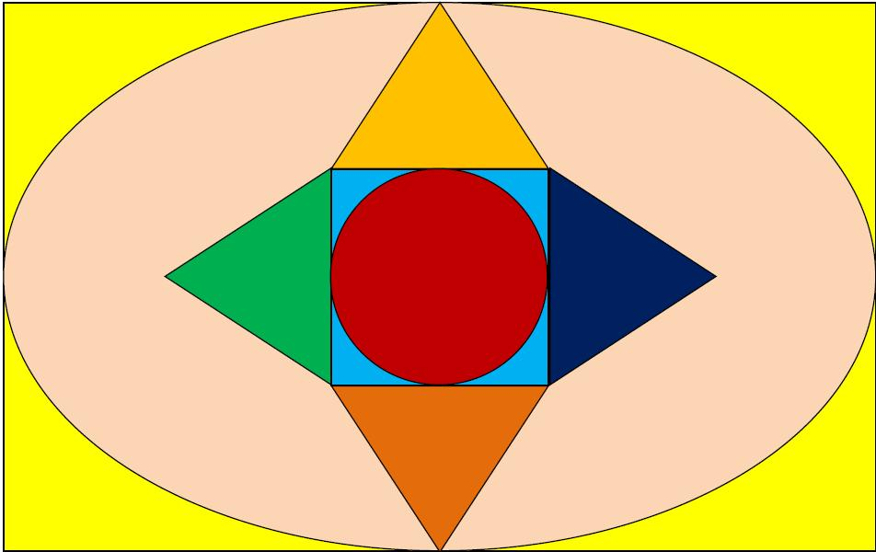
A general arrangement can be represented as:
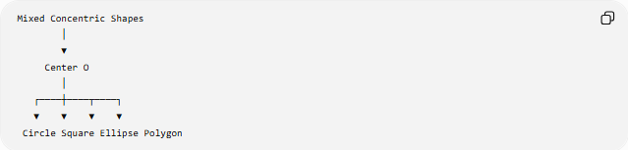
Mixed Concentric Shapes
│
▼
Center O
│
┌────┼────┬────┐
▼ ▼ ▼ ▼
Circle Square Ellipse Polygon

Mathematical Representation
# Source: AI Source: Provided by: [Data Path: Persons Table -> ID Column: 1, Name_En Column: Motasem Essam] -> From: [ChatGPT] on [7/25/2026]
There is no single universal equation for mixed concentric shapes because the individual shapes can have different mathematical descriptions.
Each shape can be represented independently while sharing a common center.
For example:
Circle
$${\left(x-h\right)}^{2}+{\left(y-k\right)}^{2}=r^{2}$$
Ellipse
$$\frac{{\left(x-h\right)}^{2}}{a^{2}}+\frac{{\left(y-k\right)}^{2}}{b^{2}}=1$$
Regular polygon
Its vertices can be positioned around the same center $O=\left(h , k\right)$.
For a regular $n$-gon with circumradius $R$, vertex $i$can be represented by:
$$x_{i}=h+R\cos{θ_{i}} \\ y_{i}=k+R\sin{θ_{i}}$$
where:
$$θ_{i}=θ_{0}+\frac{2πi}{n}$$

Common Center vs. Common Shape
# Source: AI Source: Provided by: [Data Path: Persons Table -> ID Column: 1, Name_En Column: Motasem Essam] -> From: [ChatGPT] on [7/25/2026]
An important distinction is:
Concentricity concerns the center, not the shape type.
For example, a circle and a square can have:
$$O_{\text{circle}}=O_{\text{square}}$$
even though:
$$\text{Circle}≠\text{Square}$$
Therefore, mixed concentric shapes do not need to be geometrically identical.

Symmetry of Mixed Concentric Shapes
# Source: AI Source: Provided by: [Data Path: Persons Table -> ID Column: 1, Name_En Column: Motasem Essam] -> From: [ChatGPT] on [7/25/2026]
Mixed concentric shapes may have different symmetry properties.
For example:
- A circle has infinitely many reflection axes.
- A square has four reflection axes.
- A regular hexagon has six reflection axes.
- An irregular curve may have no reflection symmetry.
If the individual shapes have compatible symmetry axes, the complete arrangement can also exhibit symmetry.
However:
Sharing a center does not automatically mean that the complete mixed arrangement has the same symmetry as every individual shape.

Scaling and Dilation
# Source: AI Source: Provided by: [Data Path: Persons Table -> ID Column: 1, Name_En Column: Motasem Essam] -> From: [ChatGPT] on [7/25/2026]
Some mixed concentric arrangements can be produced using dilation.
For a shape $S$centered at $O$:
$$S^{'}=D_{O,k}\left(S\right)$$
However, when different shape types are used, the shapes do not necessarily have to be related by the same dilation.
For example, a circle and square can share the same center without one being a dilation of the other.

Mixed Concentric Shapes vs. Uniform Concentric Shapes
# Source: AI Source: Provided by: [Data Path: Persons Table -> ID Column: 1, Name_En Column: Motasem Essam] -> From: [ChatGPT] on [7/25/2026]
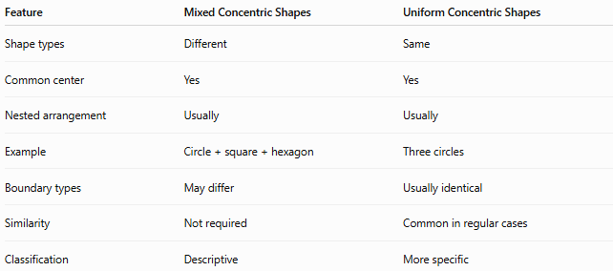
Feature | Mixed Concentric Shapes | Uniform Concentric Shapes
Shape types | Different | Same
Common center | Yes | Yes
Nested arrangement | Usually | Usually
Example | Circle + square + hexagon | Three circles
Boundary types | May differ | Usually identical
Similarity | Not required | Common in regular cases
Classification | Descriptive | More specific

Mixed Concentric Shapes vs. Nested Shapes
# Source: AI Source: Provided by: [Data Path: Persons Table -> ID Column: 1, Name_En Column: Motasem Essam] -> From: [ChatGPT] on [7/25/2026]
These terms are also different.
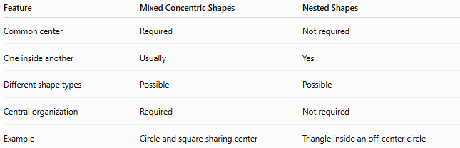
Feature | Mixed Concentric Shapes | Nested Shapes
Common center | Required | Not required
One inside another | Usually | Yes
Different shape types | Possible | Possible
Central organization | Required | Not required
Example | Circle and square sharing center | Triangle inside an off-center circle
A set of shapes can therefore be nested without being concentric.

Examples

Example 1 — Circle and square
# Source: AI Source: Provided by: [Data Path: Persons Table -> ID Column: 1, Name_En Column: Motasem Essam] -> From: [ChatGPT] on [7/25/2026]
A circle and square share center:
$$O=\left(0 , 0\right)$$
The circle has:
$$r=5$$
and the square is centered at the same point.
They form a mixed concentric arrangement.

Example 2 — Circle, hexagon, and square
# Source: AI Source: Provided by: [Data Path: Persons Table -> ID Column: 1, Name_En Column: Motasem Essam] -> From: [ChatGPT] on [7/25/2026]
Suppose:
$$O_{\text{circle}}=O_{\text{hexagon}}=O_{\text{square}}=O$$
The three shapes are different, but they are centrally organized around the same point.
This is a multi-type mixed concentric arrangement.

Example 3 — Circle and ellipse
# Source: AI Source: Provided by: [Data Path: Persons Table -> ID Column: 1, Name_En Column: Motasem Essam] -> From: [ChatGPT] on [7/25/2026]
Consider:
$$x^{2}+y^{2}=25$$
and:
$$\frac{x^{2}}{49}+\frac{y^{2}}{25}=1$$
Both are centered at:
$$\left(0 , 0\right)$$
but one is circular and the other is elliptical.
They form a mixed curve-based concentric arrangement.

Classification Summary
# Source: AI Source: Provided by: [Data Path: Persons Table -> ID Column: 1, Name_En Column: Motasem Essam] -> From: [ChatGPT] on [7/25/2026]
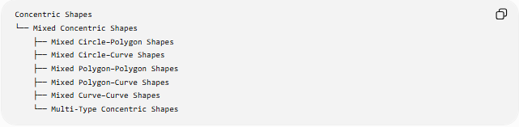
Concentric Shapes
└── Mixed Concentric Shapes
├── Mixed Circle–Polygon Shapes
├── Mixed Circle–Curve Shapes
├── Mixed Polygon–Polygon Shapes
├── Mixed Polygon–Curve Shapes
├── Mixed Curve–Curve Shapes
└── Multi-Type Concentric Shapes
A broader classification can be represented as:
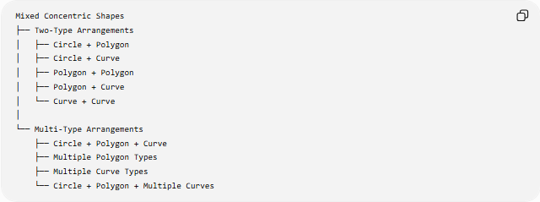
Mixed Concentric Shapes
├── Two-Type Arrangements
│ ├── Circle + Polygon
│ ├── Circle + Curve
│ ├── Polygon + Polygon
│ ├── Polygon + Curve
│ └── Curve + Curve
│
└── Multi-Type Arrangements
├── Circle + Polygon + Curve
├── Multiple Polygon Types
├── Multiple Curve Types
└── Circle + Polygon + Multiple Curves

Key Points
# Source: AI Source: Provided by: [Data Path: Persons Table -> ID Column: 1, Name_En Column: Motasem Essam] -> From: [ChatGPT] on [7/25/2026]
- Mixed concentric shapes combine different types of geometric shapes around a common center.
- The shapes may be circles, polygons, ellipses, or other centrally organized curves.
- The common center is the defining organizational feature.
- The shapes do not need to be identical.
- They do not need to be similar.
- They do not necessarily have the same symmetry.
- A mixed concentric arrangement may contain two or many different shape types.
- “Mixed concentric shapes” is primarily a descriptive classification, rather than a strict standard mathematical shape category.
- Concentricity describes the central relationship; “mixed” describes the variety of shapes.
- Nested shapes are not necessarily concentric because nesting alone does not require a common center.

Conclusion
# Source: AI Source: Provided by: [Data Path: Persons Table -> ID Column: 1, Name_En Column: Motasem Essam] -> From: [ChatGPT] on [7/25/2026]
Mixed Concentric Shapes are arrangements in which different geometric shapes share a common center or central reference point. They can combine circles, polygons, ellipses, and other curves in a nested or centrally organized structure. The concept is useful for describing complex geometric arrangements where central organization is maintained even though the individual shapes are different.

